We Are #1 Research Document

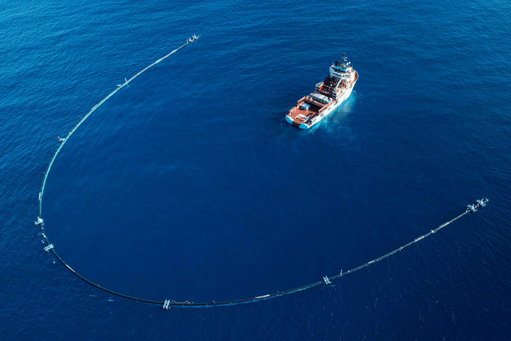

The Ocean Cleanup

Contents

Goal selection process 3

The Ocean Cleanup Research 4

Empathy map company 5

Problem statement 6

Empathy map target group 7

Solution 9

APA 10

# Campaign Selection Process

Pictured: Brainstorming session underway with all the ideas still on the board.

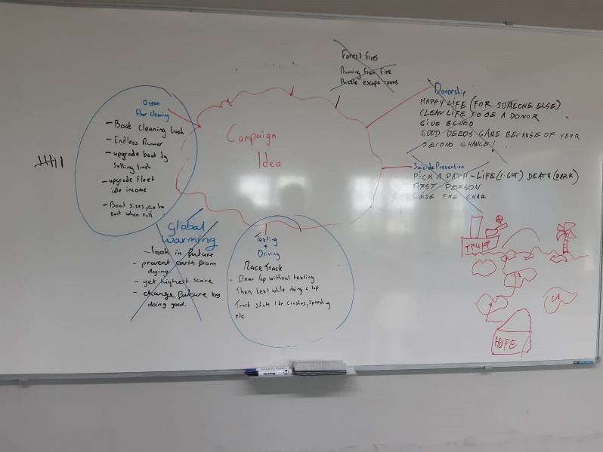For the project, we started with looking through campaign websites and google to find ones that spoke to us or stood out, we then put those on a whiteboard. After finding a bunch(In the end, 10 in total) We started writing possible ideas for each campaign and seeing what we could actually do with them(Multiple ideas per) and scrapping as we went along ones we couldn’t think of anything for until each one had at least one idea.

We then started scrapping ones that wouldn’t be fun to make until we had 2 left, texting + driving & ocean cleaning. At this point we took a vote on the 2 to see which one we would research and explore fully and the vote went unanimously with Ocean Cleanup.

Pictured: The same ideas with some of them taken off or crossed out and the final two circled.

# The Ocean Cleanup Research

So to start with the Ocean Cleanup, it started technically in 2010 when the founder, Boyan Slat went scuba diving in Greece and saw all the plastic. He wanted to do something about it and after writing a paper about in High School actually got invited to a TEDx talk in 2012 about his idea. Interest died down a bit after that but it stuck with him when he went to study Aerospace Engineering. He couldn’t let go and after 6 months he quit his study and founded the organization: Ocean Cleanup. In March 2013 the TEDx talk got picked up by the news again and his initially small organization got over 90.000 in donations and he was able to hire his first team to start tackling the issue.

Since then it’s grown a lot, in 2019 they launched the second version of their cleaning system already as they test more and make iterations on their system to achieve their goal of clearing up 50% of the plastic in the great pacific patch.

Cleaning up the ocean is their primary goal but by providing information and hosting campaigns they also have secondary goals, mostly of informing people. Not only of the damage that has been done or about the great sea patch but also of the fact that something can be done. It’s a message of hope. “We can do something about this.” From this message we made the following empathy map:

# Empathy Map Organisation

Empathy Map for: Ocean Cleanup

*Who are we trying to empathize with?*  
Ocean Cleanup, an organization dedicated to cleaning the ocean of plastic and spreading awareness of the large plastic waste in the oceans.

*What do they need to do?*  
They need to get donations so they can grow their operation and in general to inform people of what’s going on, they also have a message of hope and a “Yes, we can clean it up!” they want to spread to new audiences.

*What do they see?*  
The fear of others, a lot of research on the waste in the ocean and the fact that they can clean it up. The support from the community.

*What do they say?*  
They talk about their success and the future of their project, they talk about their hope and their research to show what they do is possible.

*What do they do?*  
They go out there and they clean up the ocean, they do loads of research on the health of the ocean and the things they do and they try and inform people of what they’re doing.

*What do they hear?*  
They hear messages of hope and support, people believe in them and what they do and their research shows what they do is possible. They however also hear the messages of critics and nay-sayers who believe they are dreaming too much.

*What do they think and feel?*  
*Pains:* That people lost faith in them  
That people lose faith in the project  
That they run out of resources  
  
*Gains:* To clean up the oceanTo give people hope  
To prove themselves  
To show that we can better our planet

# Problem Statement

Ocean Cleanup wants to inform as many people as possible about the issues our oceans face as well as give hope to people with the things that we are doing to stop it, although the negative message is often spread without them, the real issue is making sure the positive message is spread as well.

# Target Group

The target group that Ocean Cleanup is university educated adults, as most of their publishing are very scientific and relatively advanced. We should however find a good way to reach a new target audience since the point of the campaign is to spread awareness and information.

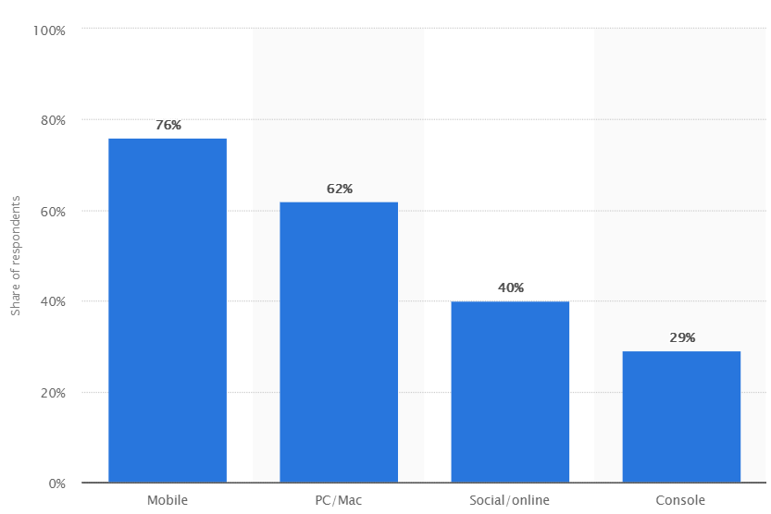  
Pictured: Division in platform between gamers in survey amongst Akamai clients

Since we want to reach large new audiences by developing a product in Unity3D, the biggest audience we could possible reach is clearly in the mobile market. That’s just games alone, the potential audience is even bigger: 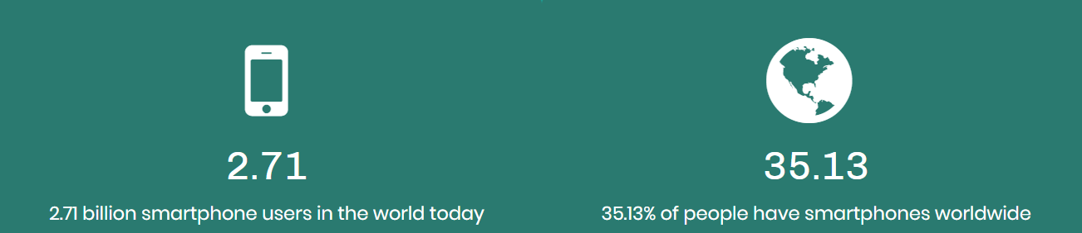  
Pictured: The total amount of smartphones as a number and percentage from GSMA Intelligence

That’s 35% of every living human alive right now. We can reach an audience far bigger with a mobile game than we ever could with any potential PC program or even TV, and since the biggest goal is to reach as large an audience as possible with our message of hope, it seems like a logical choice to then go with a mobile game. The question then becomes who to develop it for? Google made a survey on the types of players that play mobile games and categorized them into five categories 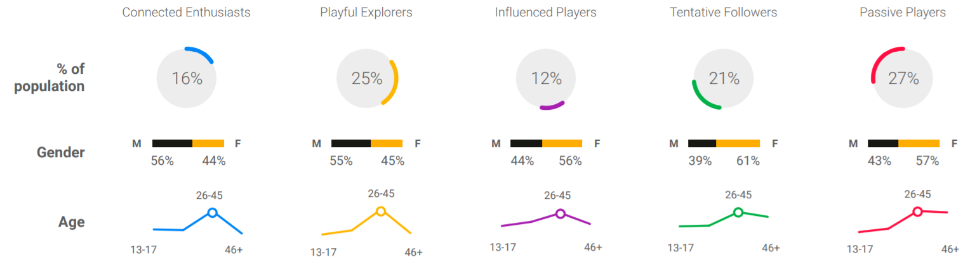  
Pictured: The % of population, gender division and age of the 5 mobile game consumer types.

Now we need to choose from these categories. Although the connected enthusiasts, influenced players and tentative followers tend to play new games thanks to word of mouth, only the connected enthusiasts are really willing to try new things. This is due to the fact that they’re high passion and the others are not.

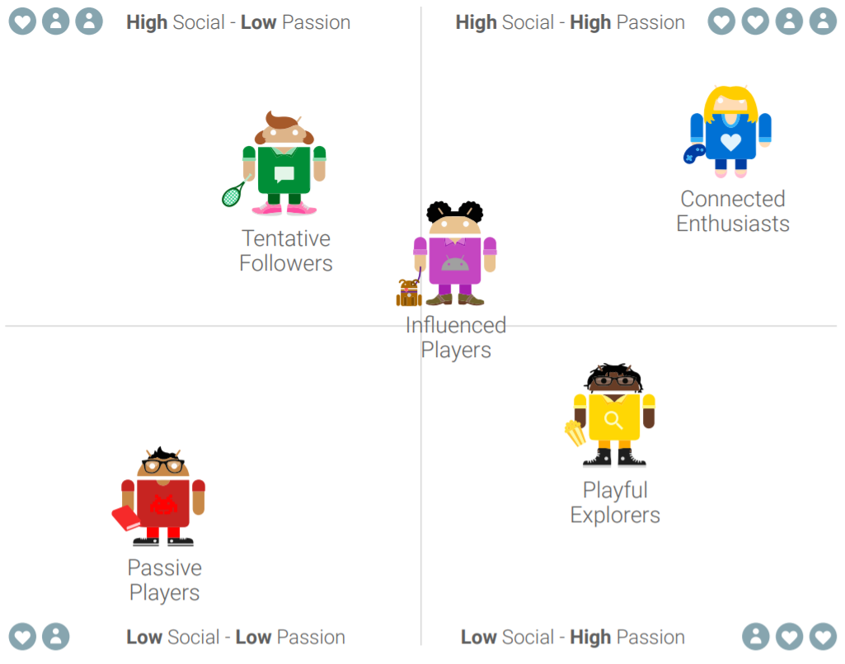  
Pictured: Social vs Passion for mobile game consumer types.

In fact, all of the last 3 player types are slower adapters. They are also all less likely to give their money. Now this of course doesn’t exactly correlate to their likeliness to spend money on donations but it’s still a factor to take into account. As shown above the playful explorers or the connected enthusiasts are the most likely to try new things, together they also cover over 41% of all mobile gamers.

Now then, what game do we make for this audience?

# Solution

We’ve found our player types in the schematic but what game will be most popular with them?

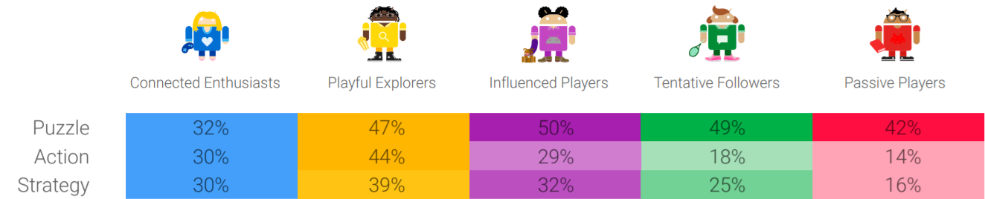

The top 3 most popular games across all genres show puzzle as the most popular by far, but for our player types we have 3 choices. Puzzle, action and strategy. From here on we decided to come up with games within these archetypes that we thought would be really fun, especially since our player group likes a potential challenge and then we’d make a choice based on how fun we thought the ideas were. It was a surprisingly easy choice with a few games ideas but one that really stood out to us as fun and that we’d actually want to download and play ourselves. This was an endless runner-type game, with a bit of bullet hell thrown in. Combining some of the most popular games in the action genre. In the end, though, the most important thing is conveying that message of hope with this new audience. For this reason the game is about you playing as one of the boats that takes care of the trash and seeing the ocean clean up. We can do it. You can do it.

# Sources

<https://theoceancleanup.com/milestones/how-it-all-began/>

<https://theoceancleanup.com/about/>

<https://theoceancleanup.com/updates/>

<https://www.statista.com/statistics/608933/gaming-companies-customer-preferred-gaming-platforms-worldwide/>

<http://services.google.com/fh/files/blogs/who_plays_mobile_games.pdf>

<https://www.bankmycell.com/blog/how-many-phones-are-in-the-world>